Great and Small Kindergarten Newsletter
November 2020

What’s on…

Promoting positive wellbeing
As a childcare setting that aims to be a nurturing environment for your children, we already know the importance of healthy wellbeing and mental health in children and their families and we enjoy activities that promote this such as yoga and mindfulness. However we’d like to invite you to engage in this too. Now we’re not expecting you to get into a downward dog position but you will find a whiteboard with an update of what aspect of wellbeing we are looking at and how you could continue this at home, for the benefit of your child but also yourself, your families and friends. This week’s is about ‘acts of kindness’. If your child does or says anything kind for another person, write a little note and pop it in the jar in the entrance porch. We will then share and celebrate these acts of kindness together.  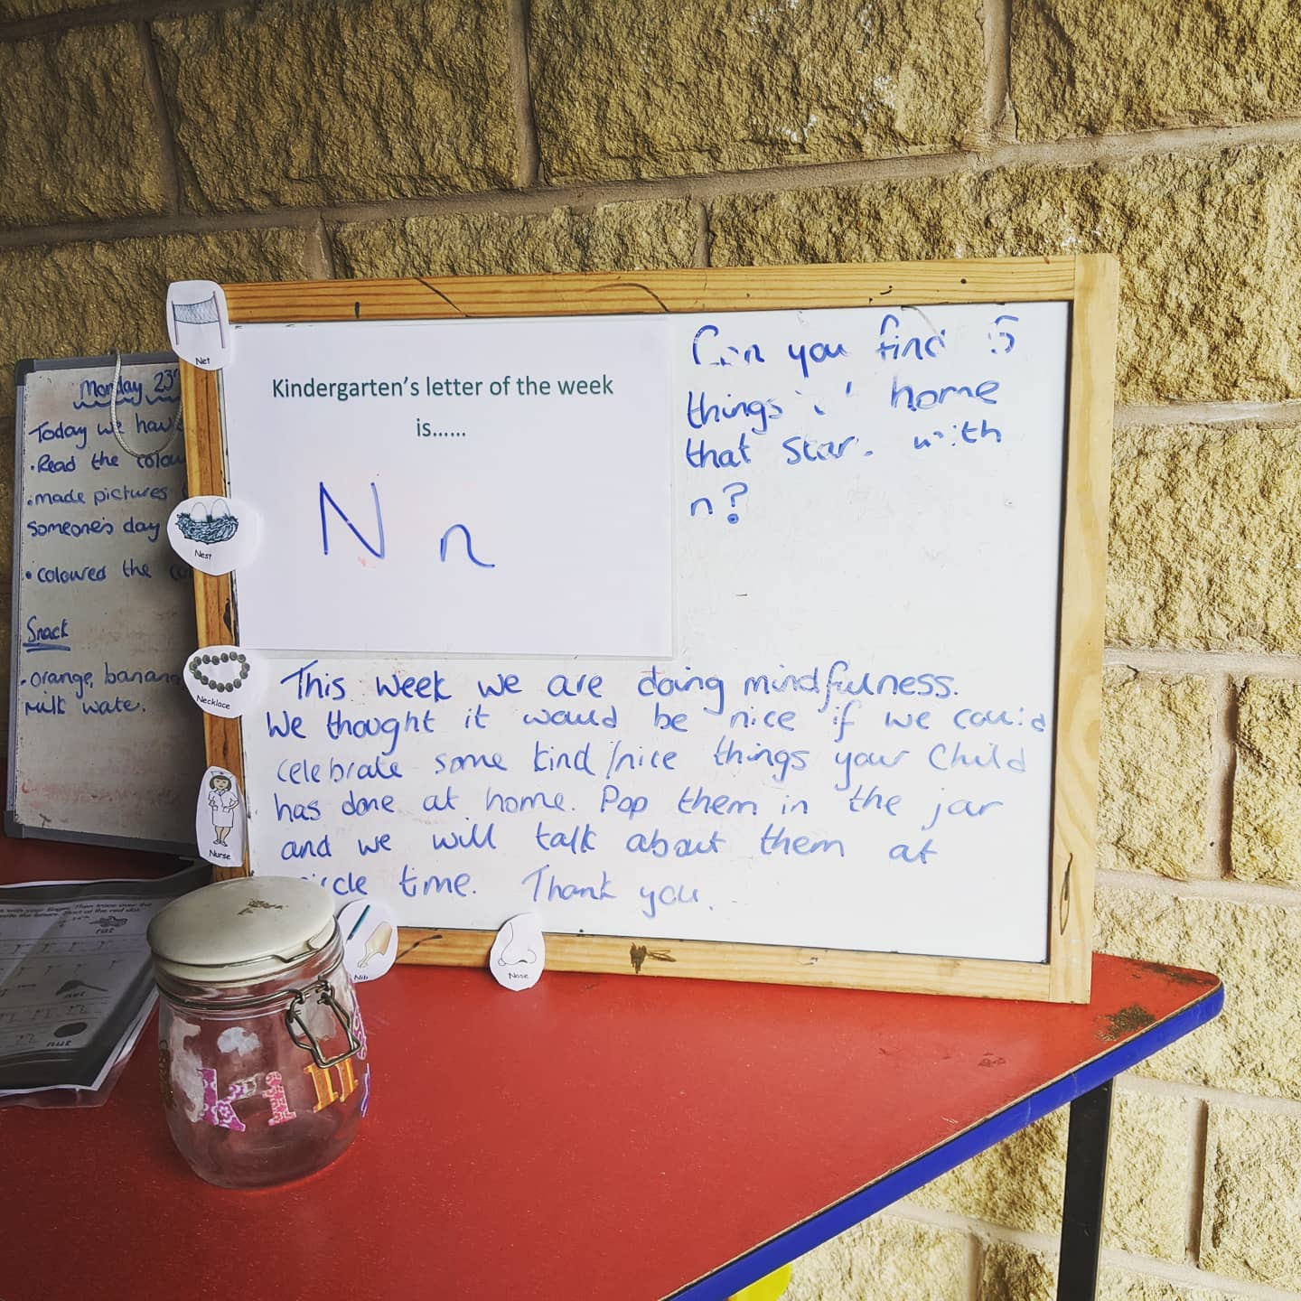 |  | Letter of the week  Phonics  You may have already noticed in the entrance porch that we are informing parents and carers of what our ‘letter of the week’ is.  In kindergarten, we have several activities and times together when we chat about this letter, listen out for it in stories, have matching activities or ‘spot the letter’ plus put out objects that start with the letter. This is to help children start to use phonics to help them go on to read and write.  You can help with this too by doing the little activities we suggest with your child for example ‘spot 5 things at home that beginning with the letter N’ or ‘take a photo of 3 things that beginning with S and share these with us on Tapestry’.
Remember: if your child or anyone in your household shows any symptoms of Covid 19, please do not bring your child to kindergarten and follow the government guidance.
Go to www.gov.uk/coronavirus for current guidelines

Upcoming dates to put in your diary….
Christmas Jumper Day –  Friday 11th December. Children can wear a Christmas jumper or top that day.  Christmas Party Days –  Tuesday 15th December and Friday 18th December  Close end of day Friday 18th December.  Reopen Tuesday 5th January 2021 |  |  | The weather is certainly getting colder now but we still enjoy our outdoor play so please ensure that your child comes dressed appropriately for the weather or put a hat, scarf and gloves in their bag
Get a £20 gift card!! | If you know anyone who is looking for childcare for their little one, your recommendation would be hugely appreciated! Should you refer anyone to us who then registers with us to start in the new year or puts their child’s name on the waiting list, you will both receive a Tesco gift card when the child starts with us as a thank you!!

