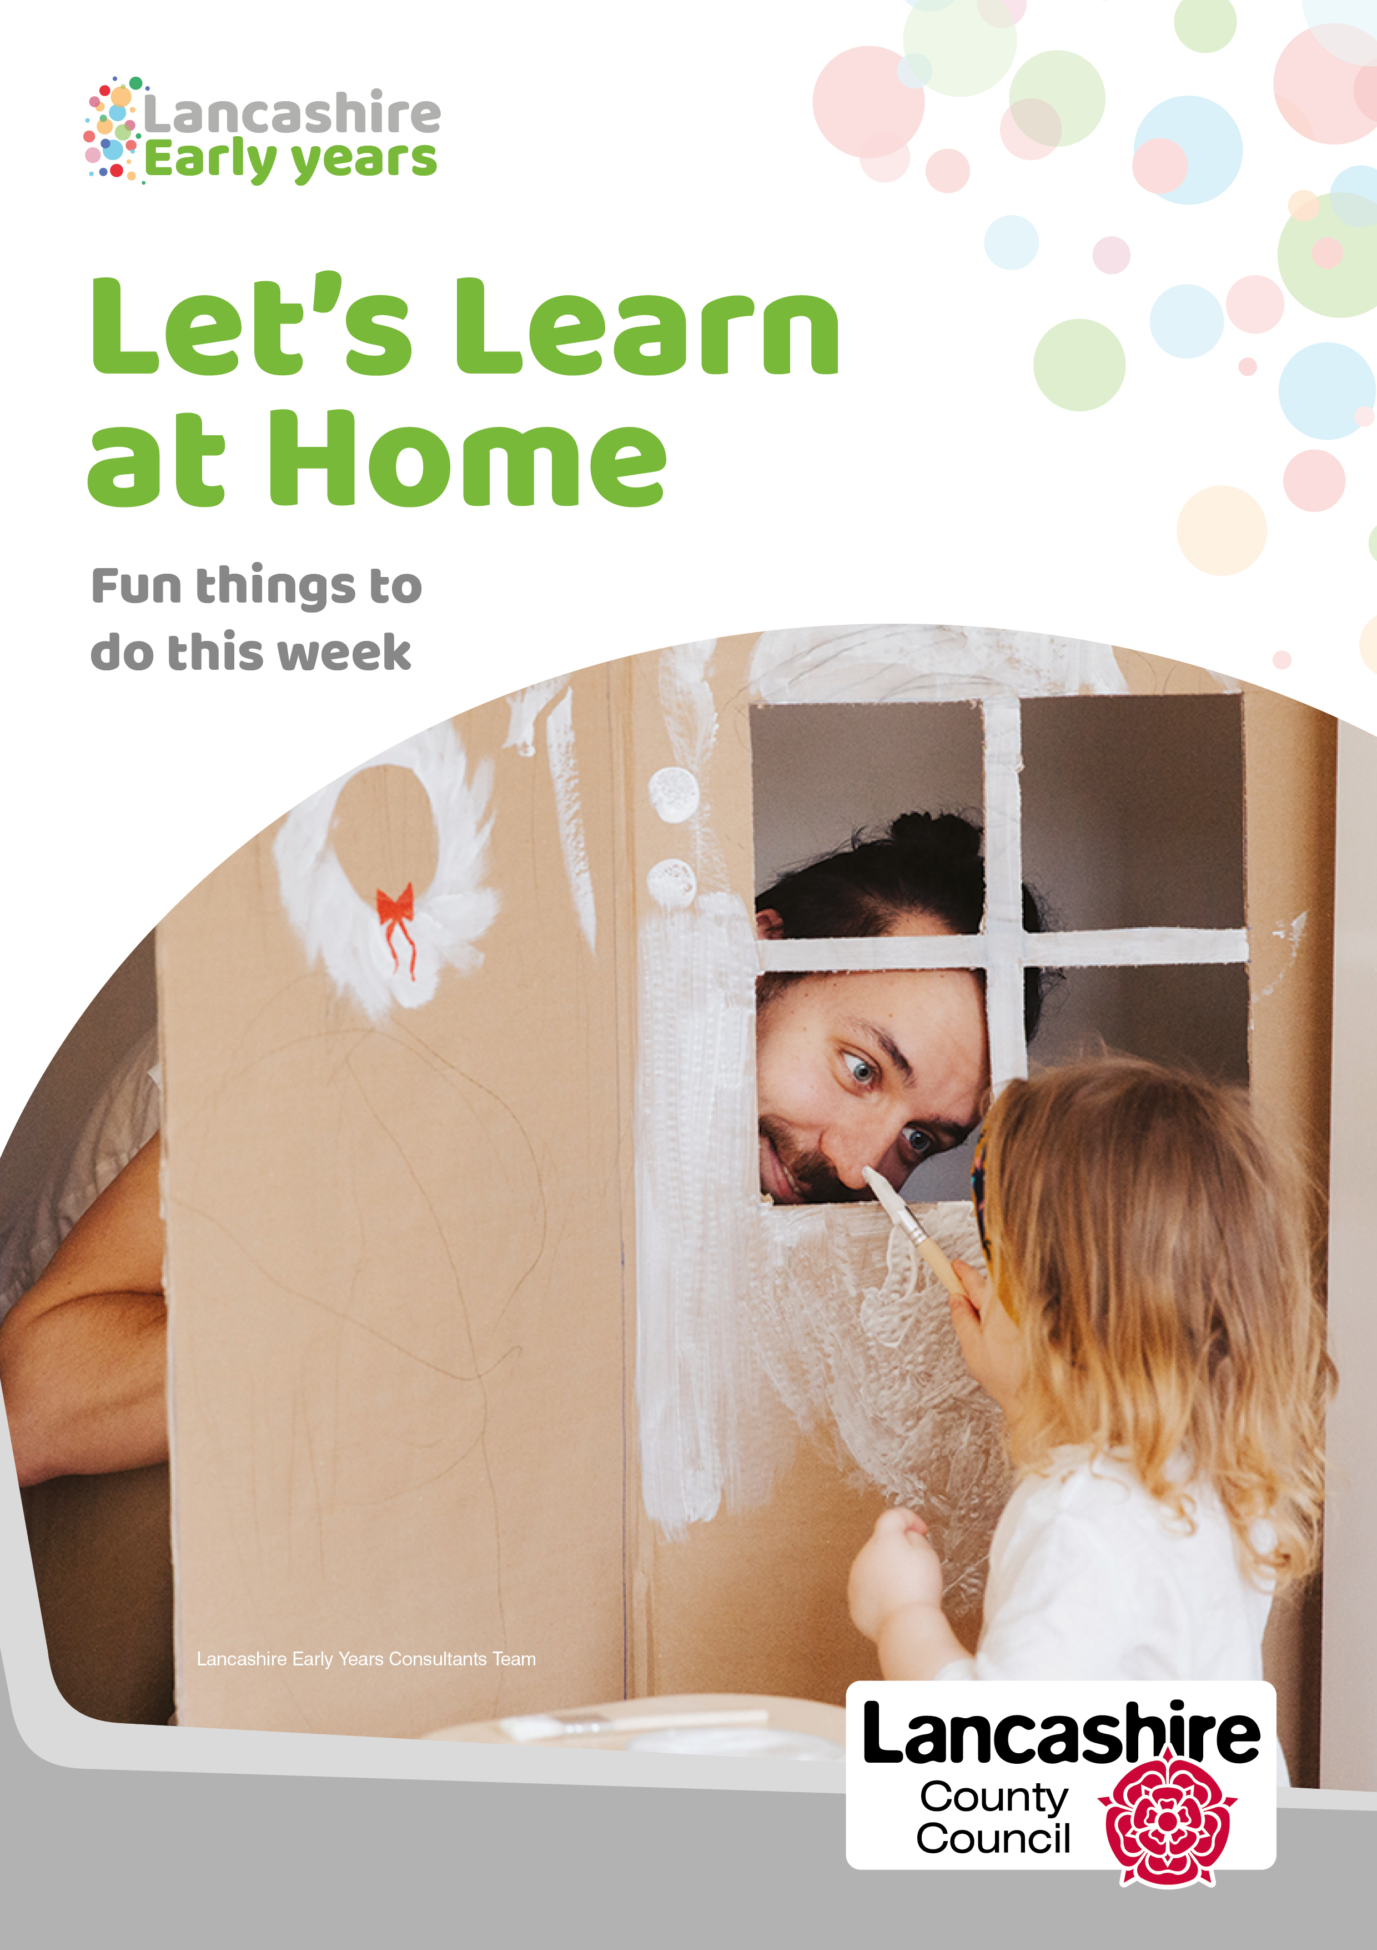

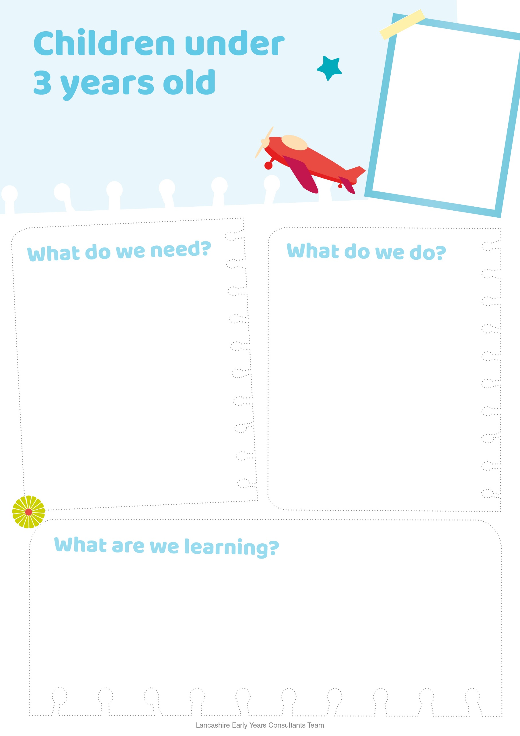

* Take your child to the library
* Provide a variety of different reading materials
* Let them choose the books they want to read and share with you
* Repeat the stories if they want to hear them again and again
* Let them hold the book as you share the story with them
* Talk about what is happening in the pictures
* Let them help turn the pages
* Use different voices to tell stories and encourage your child to join in
* Use props to support story telling
* Read every day with them, especially at bed time

**Let's Read Together**

* Picture books
* Homemade books with recognisable images e.g. families, pets and familiar objects
* Books with stories, rhymes, songs, poems or jingles
* Lift the flap books
* Age appropriate stories
* Factual books
* Books to support feelings
* Props to support story telling e.g. puppets, animals, soft toys and real objects
* How to enjoy books
* How to handle books
* Communication and language
* Literacy
* How to listen
* Personnel and social skills
* Fine motor skills
* How to make choices
* Begins to use instruments to make sounds to the music
* Shows interests in sounds, songs and rhymes
* How to build relationships with special people
* Moves in response to hearing rhythms

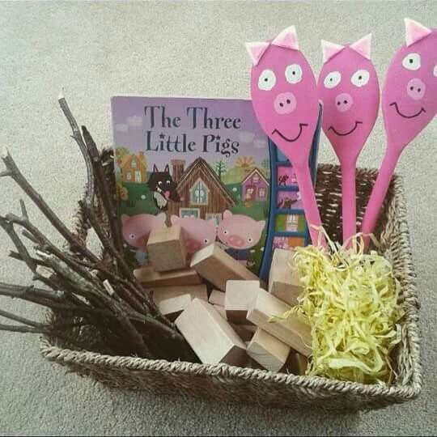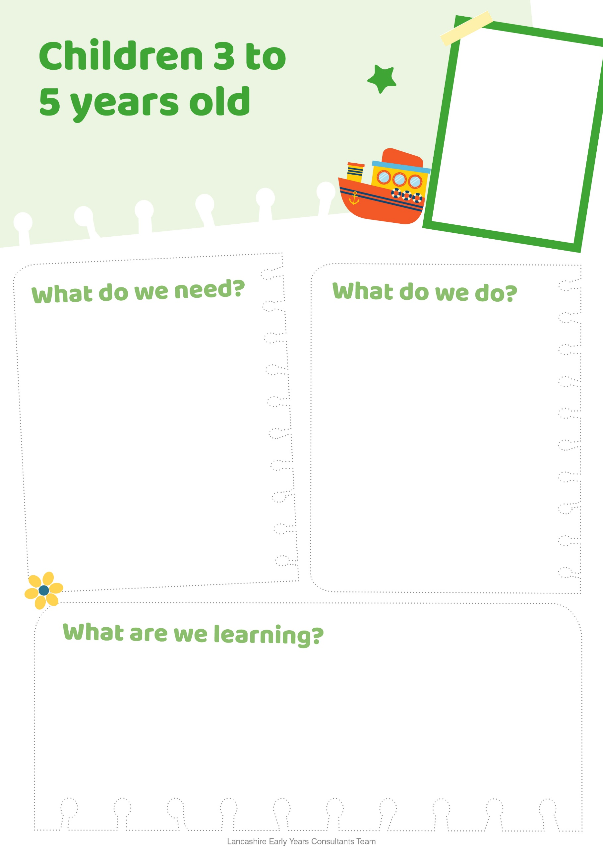

* To foster a love of books with your child
* Enjoy stories
* Listening skills
* How to retell a story
* Communication and language skills
* Paint the three little pigs on wooden spoons to use as puppets
* Use the straw, sticks and bricks as props to tell the story
* Try to build the houses with your child
* Don’t forget to be enthusiastic when telling the story
* Try blowing the house down when made

**The Three Little Pigs**

* The Three Little Pigs story book
* Sticks, bricks and straw
* Wooden spoons
* Paint
* Basket, box or bag to keep the resources in.

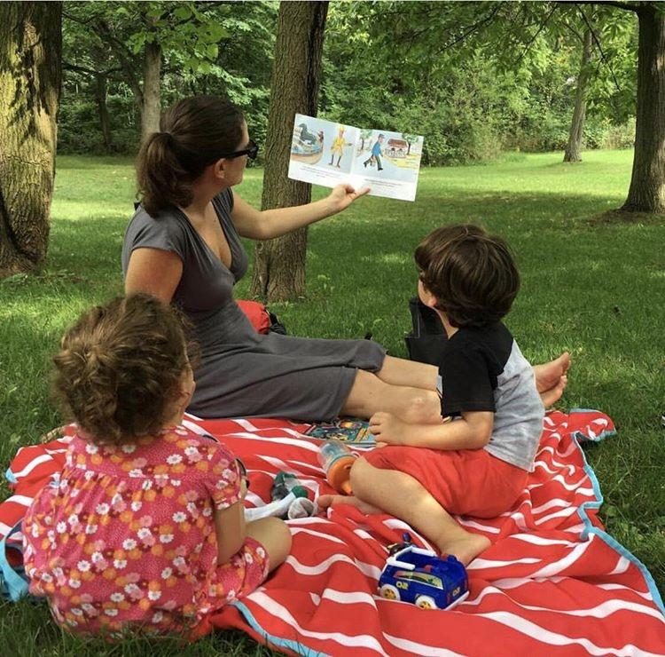

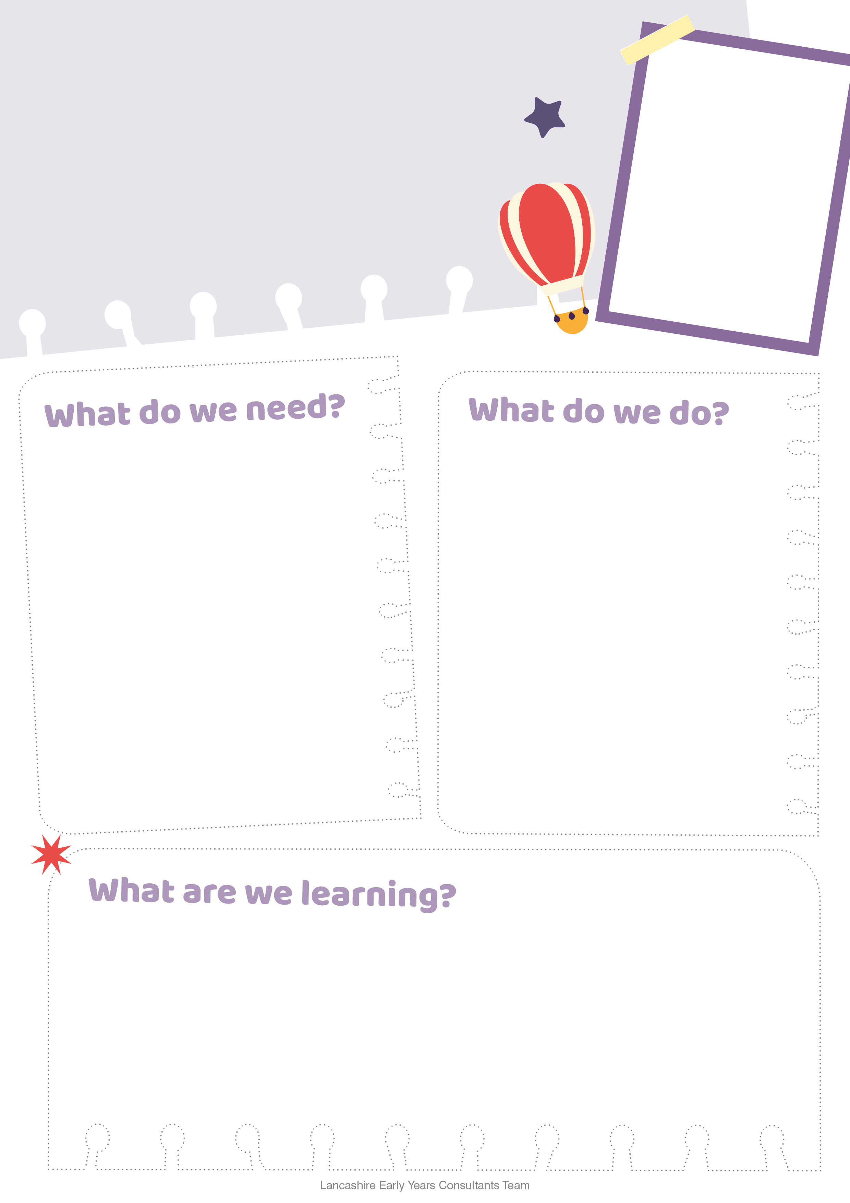

* Develop early reading skills
* To value books and stories
* Spark your child's imagination and curiosity
* Develop language and listening skills

Make stories come alive by reading them outdoors.

**In the woods**

The Gruffalo

Little Red Riding Hood.

Foggy Foggy Forest

**On the beach**

Sharing a shell

What the ladybird heard at the seaside

**In the park**

Shark in the Park

Percy the Park Keeper stories

* Your child can choose the story to read outdoors
* Take along a rug and maybe a snack
* Find a quiet space to share the story
* Act out the story with your child
* Use torches and lanterns in the dark!
* Child could dress up as one of the book characters

